**Chapter 1 Introduction to Repeated Measurements**

P13 paired t-test VS two-sample t-test

P20~23 progression, effect of treatments,

separate longitudinal from cross-sectional effects

**Chapter 2 Simple methods**

P30~32 ignore correlation: overestimated for within-subject effects, underestimated for between-subject effects

P33~37 analysis at each time point, Analysis of Area Under the Curve (AUC), Analysis of endpoints, Analysis of covariance, Analysis of increments

**Chapter 3 Marginal Regression Models/ Multivariate Models**

P53~54, P113~115 ML estimator vs REML estimator

P62~68 Unstructured model

P69~86 (Semi-) Parametric model

P69~78 linear trend and nonlinear trend model

P79~82 linear spline model

P83~86 Natural cubic/ B-splines

P92 Unstructured covariance

P93 Compound symmetry covariance

P94~95 Autoregressive of order 1 (AR-1) covariance

P96~97 M-dependence/Toeplitz

P98~102 Continuous AR1/ Exponential serial correlation/ Gaussian serial correlation

P131~136 Hypothesis testing for covariances

P137~152 Hypothesis testing for β

P156~165 Residual analysis

**Chapter 4 Linear Mixed Effects Models (LMM)**

P186~187 Model graph

P188~191 Model expression

P192~195 Interpretation, pairwise correlation

P205~210 Mixed model VS Marginal model

P212~216 Parameter estimation

P234~236, p237~238 Different random-effects covariance matrix D in R

P240~241 Model Building Strategy

P243~252 Hypothesis testing for covariances

P253~260 Hypothesis testing for fixed effects β

P264~275 Residual analysis

P276 Empirical Bayes estimates plots

P282~286 Multilevel Model

P289~290 Fitting Multilevel Model

**Chapter 5 Generalized Estimating Equations (GEE)**

P312~316 Logistic regression transformation, Parameter Interpretation

P330~334 Poisson regression, Parameter interpretation

P338 Poisson regression: Deviance/df ≃ 1 for a good fitting model

P343 Poisson regression for the expected rate

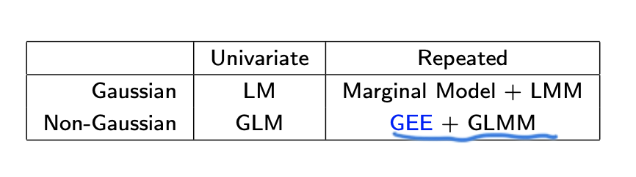

P351 GEE is not a likelihood-based approach

P352~354 Three components of GEE approach

P356~360 Properties of GEE

P362~368 “working” correlation matrix: Independence, Exchangeable or Compound symmetry, Autoregressive (AR-1), Unstructured, M-dependence or Toeplitz

P372, P381, P392 Hypothesis testing for logistic regression

P401, 402 Hypothesis testing for Poisson regression

**Chapter 6 Missing Data in Longitudinal Studies**

P409 Type of subject

P411 Missing data indicator

P413~414 Missing Completely at Random (MCAR)

P415~419 Missing at Random (MAR)

P420~421 Missing Not at Random (MNAR)

P424 Complete Cases Analysis

P425 Last Observation Carried Forward (LOCF)

P426 Unconditional Mean Imputation

P427~430 Conditional Mean Imputation

P431~437 Multiple Imputation

P439~443 Missing Not At Random Models

P440 Selection models

P441 Pattern mixture models

P442 Shared parameter models

**Chapter 7 Generalized Mixed Effects Models (GLMM)**

P461~518 GLMM - Mixed Effects Logistic Regression and Poisson Regression

P465~478 Interpretation, βSS VS βM

P480~490 Estimation: Approximation of integrand (Laplace approximations), Approximation of data (Penalized quasi-likelihood & Marginal quasi-likelihood), Approximation of integral (Non-adaptive or Adaptive Gaussian quadrature methods)

P490~513 Logistic Regression Example

P513~517 Logistic Regression Example

GLMM: MCAR and MAR

GEE: MCAR